Initial Setup:
https://digigeodata.com//webmail
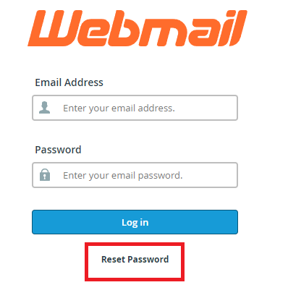
Reset your password
your email: xxxxxxxx
Temp password: xxxxxxxxx
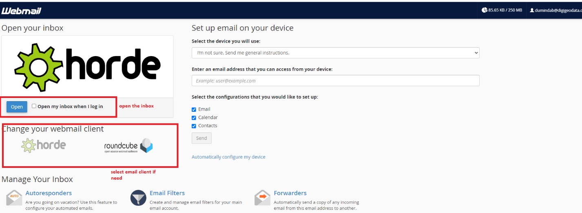
Outlook
Files/info/Add Account
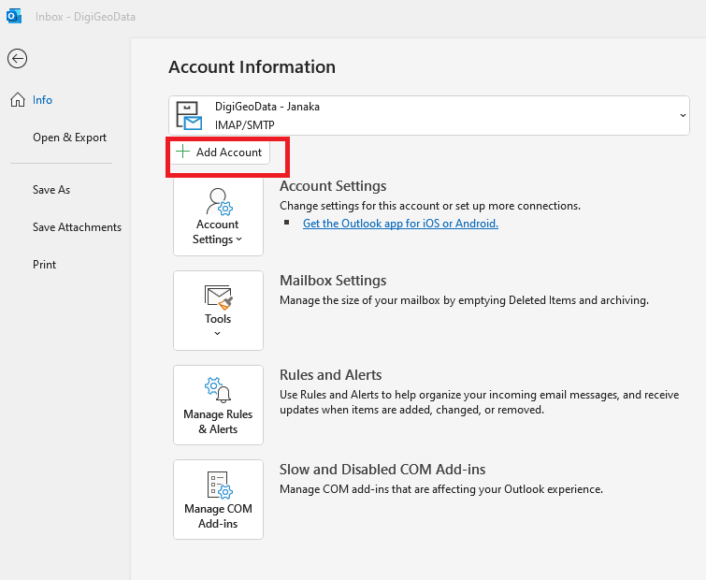

Enter your email and go to advanced setting, Click IMap and enter your password
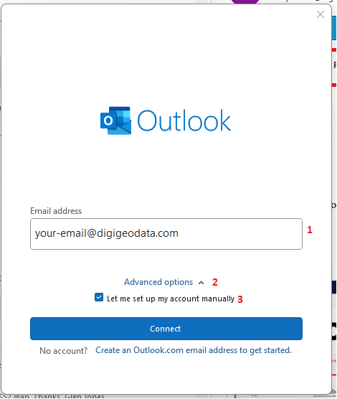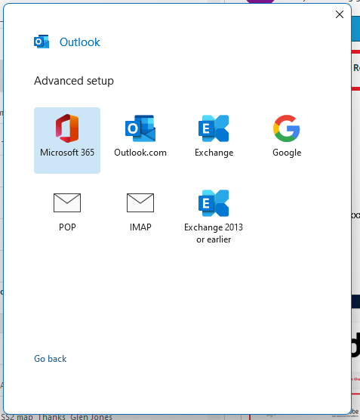

Addtiona manual setiing if need
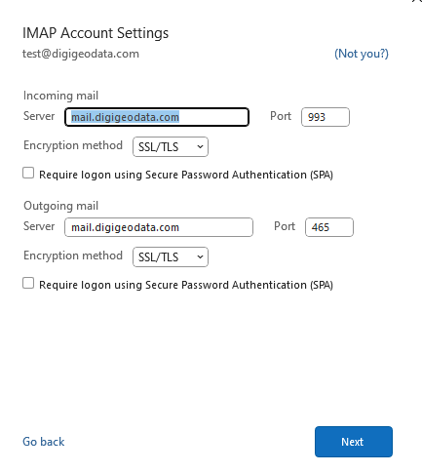

Older version of outlook (see below for setting)
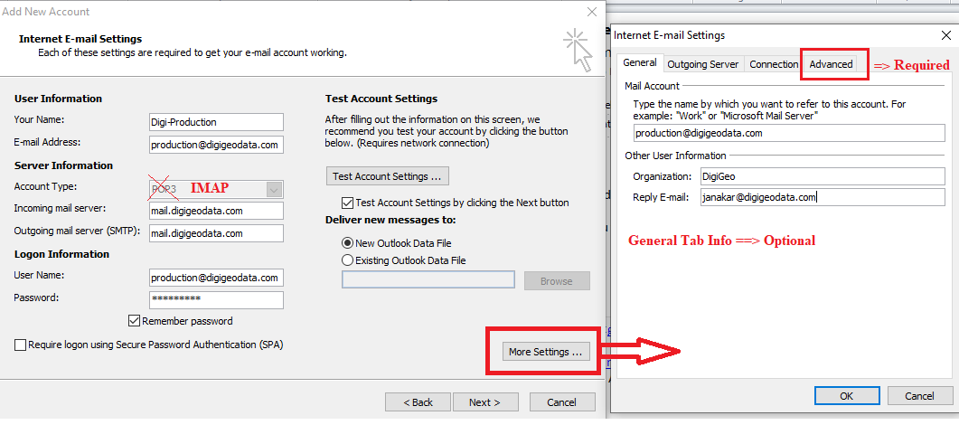

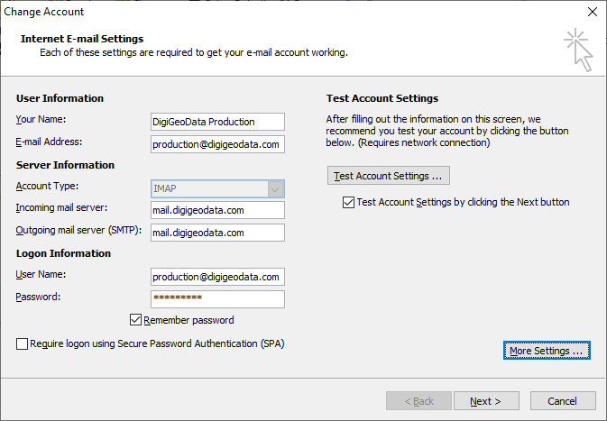
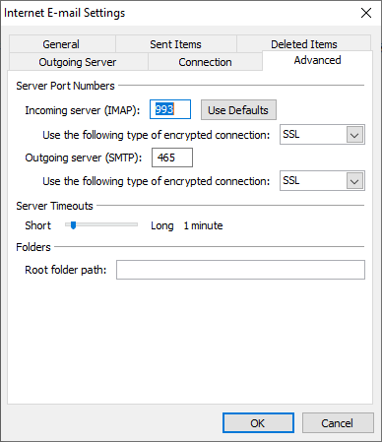
Gmail Setup
- Log in to your main Gmail account.
- Click the Settings gear icon and click “see select Settings”

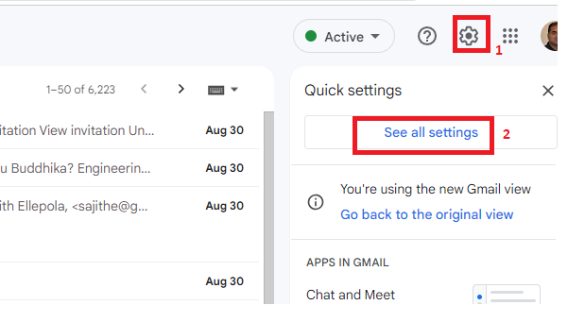
- Click the Accounts and Import or Accounts tab.
- Click Add a mail account in the "Check mail from other accounts" section.
- Follow the steps on the screen, then click Next or Sign in.

